About us
Name LES JARDINS OSTREICOLES DE TATIHOU
Address 12, rue des Parcs – 50550 Saint-Vaast-La-Hougue – France
Product Cupped Oysters – Fine and Spéciale
Activity Oyster Farming
Employees 13
Creation date 1994
2019 Turnover 1 633 780 € whose 38 % on Export
Main Markets France, U.E (Italia, Belgium, Netherlands, Sweden, Spain, Greece), South of Asia (Taïwan, Hong Kong, Malaisia)

Introduction « Les Jardins ostréicoles de Tatihou » have 15 hectares of Oysters beds situated in the bay of St Vaast La Hougue, an Historical and Famous place in France for oyster farming. Our production of 400 Tons is 100 % local, even our spat is coming from a Hatchery 20 km far from Saint-Vaast-La-Hougue.
Regarding specialists are oysters have a nustly flavor, they are crispy and crunchy, strong and sweet with a long taste staying in the mouth. Then are even speaking about a kind of flavors explosion 😊. That’s a real Taste trip in Normandy !

Contact principal :
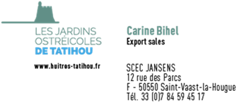

Réseaux sociaux :
Facebook : https://www.facebook.com/HuitresdeTatihou
Instagram : https://www.instagram.com/huitresdetatihou/

AWARDS
The flavour of Les Jardins Ostréicole de Tatihou oysters have regularly received prizes by the juries of the Concours Général Agricole.
Seven medals have been won since 2011, including four golds medals, the latest in 2019.


Our oysters :

fine oysters
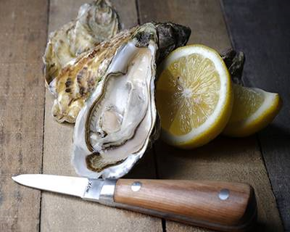
Both iodised and soft in the mouth, fleshy and with bite, the oysters from Saint-Vaast-la-Hougue are sought after by connoisseurs for their subtle nutty flavour.
Our oysters are not milky and can be enjoyed throughout the year.
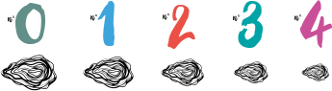

SPECIAL OYSTERS
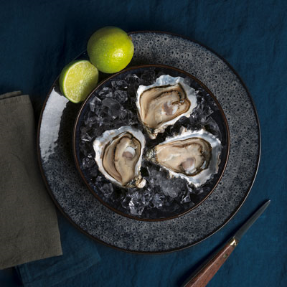
Popular with connoisseurs, the flesh of our special oysters makes up more than 10% of their total weight.
Carefully selected during their growth, they are matured in beds specifically chosen to increase their flesh ratio. They have an unrivalled crunchiness and a lingering finish.


