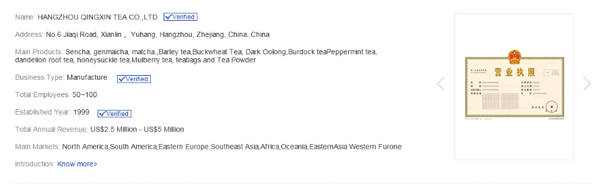

Pouvez-vous préparer les contenus cités ci-dessous et me les envoyer par email avant le 20 novembre ?

Name : Laiteries H. Triballat Rians

Address : Route de Malvette, 18220 Rians, France

Main products: Crème Brulée, Panna Cotta, Caramel Cream, Roulé Cranberry & Roulé Pineapple (Soft flavoured cow cheese).

Business type: Manufacture of dairy products

Total employee: 1000 - 1300

Total annual revenue: US$ 250 millions

Main markets: Europe, North America, Asia Oceania, South America

Introduction: Located in Rians, a village in the center of France, Laiteries H Triballat Rians is a family owned business that has been crafting authentic cheeses and desserts since four generations and is exporting worldwide. By respecting our ingredients, always as natural as possible and following traditional recipes from the beginning, we give a unique taste to our products.
Our delight: to offer you gourmet moments of French gastronomy!

- Certificats de votre activité et/ou produits (ingrédients, labellisation, etc.)

Voir email PJ

- Les présentations en anglais des produits que vous voulez mettre en avant sur l’application ainsi que des photos et vidéos de belle qualité de vos produits (50 produits au maximum)

Présentation + photos

- Panna Cotta : Produced in the village of Rians in the heart of France, our Panna Cotta is made with generous natural ingredients for a simple and delicious treat! The firm yet smooth texture of Panna Cotta is accompanied by the sweet taste of vanilla. Combined with Rians Red Fruit Coulis, this dessert offers a fruity fresh taste with a surprisingly tangy note.

Photos: https://we.tl/t-QSI8XUoypN

- Crème Brulée : Crème Brûlée is one of the most iconic French desserts. It is a rich custard cream flavored with vanilla and topped with a layer of crispy caramel
Rians took inspiration from the great chefs and sourced simple, excellent ingredients to create a sophisticated dessert at restaurant standards.

Photos: https://we.tl/t-xZLYWeROBS

- Crème Caramel: A Crème au Caramel is a rich caramel cream topped with a layer of crisp crêpe wafers. Our Crème Caramel deliver a true caramel flavor with a subtle touch of salt.

Photos: https://we.tl/t-CBolDBN5Tt

- Le Roulé Pineapple: Le Roulé is a log of cow milk fresh cheese that is hand rolled to create its wonderfully typical swirl. Pineapple is a deliciously fragrant fruit and when combined with fromage frais, the flavour is taken to a whole new level! Pieces of pineapple provide delightful bite while the creamy taste of cheese melts in the mouth.

Photos: https://we.tl/t-Q2f4lFazJZ

- Le Roule Cranberry: Rians Le Roulé is a log of cow milk fresh cheese that is hand rolled to create its wonderfully typical swirl. Cranberries are rich in antioxidants, outranking both grapes and apples. Its tangy flavour makes the perfect contrast with the creamy fresh cheese.

Photos: https://we.tl/t-ZZiPoYYpQA

Photo Banniere: https://we.tl/t-FulH4Qq7X8

- Les liens de vos réseaux sociaux et les coordonnées de votre contact principal (nom, rôle, email, téléphone, compte WeChat si vous avez)

Rians Facebook: https://www.facebook.com/LaiterieRians

Rians Instagram: https://www.instagram.com/laiterierians/?hl=fr

Contact:
Alexia Verlet
Chief Representative Singapore
Laiteries H. Triballat Rians
Email: alexia.verlet@rians.com
Mob/Whatsapp: +65 91621 271

